**Task 4: Design and Implement One Other A.I Strategy**

**World Environment: (using raylib library)**

This will be a simple demo of boss fight. A gridded world space filled out with a tilemap, having debris scatted in the room as non-navigable spaces as well as a border around the room. The objective is for the player to defeat the boss before it defeats them, using an array of different attack patterns decided via a decision tree.

**Functionality of the AI:**

The boss’s actions will be dictated by a relatively simple behaviour tree that has 4 main outcomes. A melee attack, a ranged attack, a summon, and a movement command. It has a “enrage” type mechanic for the melee and ranged attacks where they will be slightly different based off the boss’s current health pool. A diagram can be seen below showing how the decision tree acts. Decisions can be made on a cooldown of around 2 seconds, this can also be changed depending on the current situation of the fight.

Next To Player?

Checks the world distance from the boss’s current position to the players position and if the distance is small enough it passes this condition.

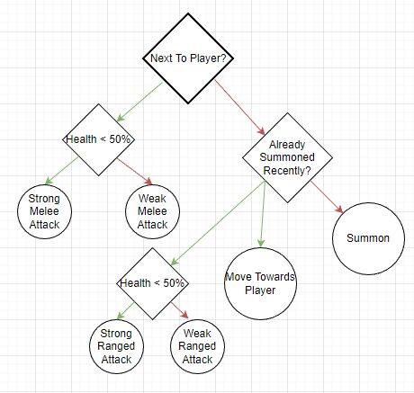Already Summoned Recently?

This is to make sure the boss doesn’t spawn and fill the room with small enemies making the fight cluttered or obscenely difficult. (This can easily be tweaked or changed for different difficulties) This will be tracked with a float counting down using frame time (deltaTime) which is set to a cooldown when the “Summon” action is called. Say 20 seconds or so.

Health < 50%

This check is for the “enrage” type mechanic. There would be two different melee and ranged attack calls which would be similar but could have: higher damage, larger radius, faster windup, etc… And this would occur when the boss’s health drops below 50% (% is subject to change during playtesting)

Summon:

Summon would create several enemy entities on the screen that would create and follow a path to move towards the player, upon reaching the player they would take damage.

Move Towards Player:

This action would involve the boss moving towards the player a set amount of grid spaces. The boss would also have an active damage hitbox during this action to force the player to move.

Ther would also need to be some type of flag indicating if the boss is completing an action in the moment or not, this would be used in connection with the 2 second decision cooldown so that the boss starts the cooldown after the action has fully been played out. If this were not to be there it could be possible the boss tries to complete two actions at once.

**Interaction with the Simulated Environment**

The boss is constantly checking the real time distance from the player in order to figure out which action would be best to take next. For example if a ranged attack would be more effective than a melee / to advance on the character.

**Difficulty Levels and Their Controls**

It would be relatively easy to introduce different diffculty levels within the AI. We could add weightings to the decision tree so that the enemy doesn’t always make the most optimal decision on how to attack. Another way to increase difficulty would be to decrease the cooldown between attacks, making the enemy more aggressive and make the player react to more actions. The “enrage” on attacks could also be tweaked to either have even stronger attacks in the phase, or have the threshold be put higher so the “enrage” phase is entered earlier.